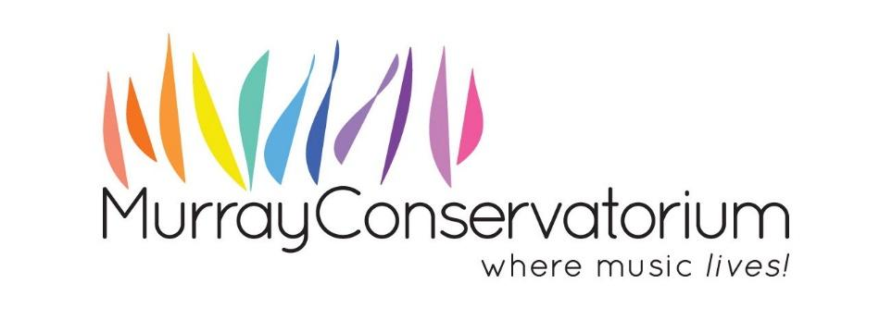

Expression of Interest Form:

Personal Information:

First Name
Last Name
Email
Street Address

City
State
Post Code
Phone

Why would you like to be on the Murray Conservatorium Board of Management?
Describe any experience you have in governance and Board development.
What positions do you hold with other Boards or organisations?

Skills Matrix. In the Right-Hand column, please identify your key strengths appropriate to each area and description.

Governance | Commercial or not for profit governance.
Strategic planning and organisational development | Business planning, innovation, and sustainability.
Education and Registered Training Organisations | Experience and connections with the education and RTO sector
Human Resource Management and WH&S | Experience, legislative knowledge and guidance in industry standards.
Financial and Risk Management | Financial planning, accounting and/or risk management expertise.
Legal | Experience with legal resolutions and processes.
Arts & Cultural Development | Experience with arts and cultural program development and evaluation.
Music participation and appreciation | Involvement in music programs or appreciation for music.
Media, PR and Marketing | Media connections and public relations knowledge.
IT systems, data security. | Contemporary experience with networks, technology, privacy, data security.
Business and community networks | Connections with businesses, and community organisations in the Murray Region.

Declaration:

I declare that:
i) I have never been, nor am I currently insolvent
ii) I have not been disqualified from acting as a director or acting in the management of a company
iii) I have never had a conviction for crimes involving dishonesty
iv) I am not a prohibited person regarding child-related employment
v) Details of my NSW Working With Children Check are added below

Signature:

Date:

Working With Children Check Number:
Date of Birth:

